CREATING YOUR PERSONAL EMAIL SIGNATURE
Outlook Interface
- On the View tab, select View Settings.
- Select Accounts
- Select Signatures.
- Select New signature, then give it a distinct name.
- Enter a name for your signature (Personal Brand? Any name)
- In the editing box below the new name, type your signature, then format it with the font, color, and styles to get the appearance you want.
Signature should have your Legal Full Name
Pronouns(optional)
Position
Company
Contact Info (Phone| Alternative Email)

- Select Save when you're done.
- With your new signature selected from the list above the editing box, go to Select default signatures and choose to apply the signature to new messages and no signature to replies and forwards.
- Select Save.
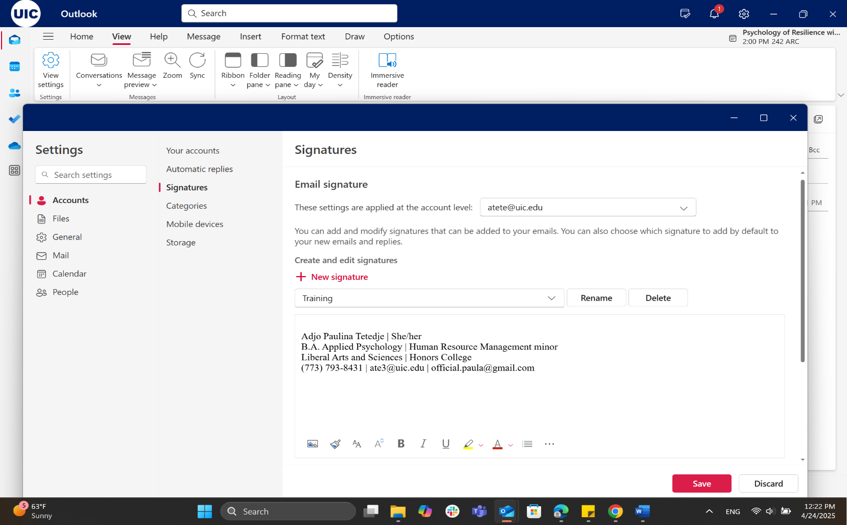







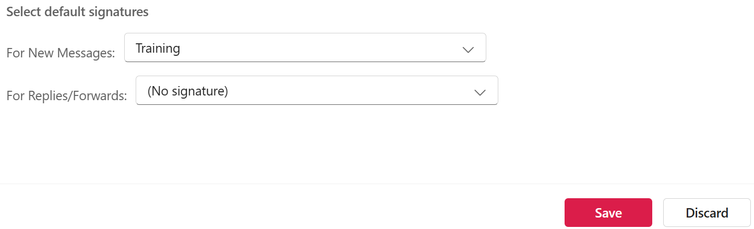
When to skip the signature
Once you’ve exchanged a few emails with someone, it’s good etiquette to remove your signature from the thread.
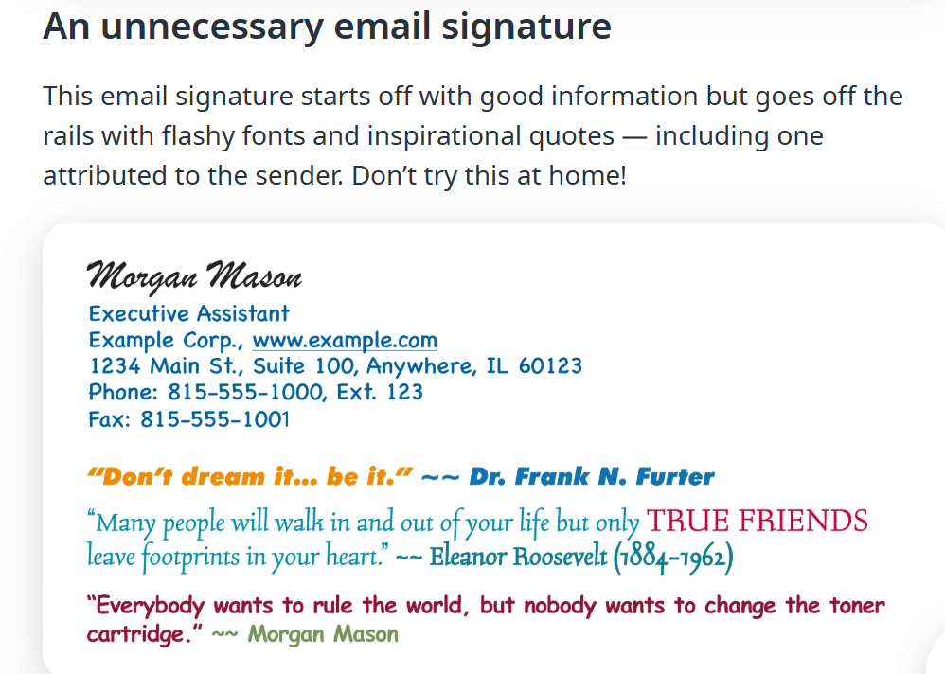
Remember THE EMAIL APPROACH
E – Ensure Clarity
M – Maintain Professionalism
A – Avoid Overloading
I – Include key details
L – Leave a Signature

HOPE YOU ENJOY YOUR TIME WITH US!

